The National Police Service adds 100 Mahindra Scorpio Pik-up vehicles to their fleet from Simba Corp
Nairobi, January 7, 2022: The National Police Service today received 100 brand-new Mahindra Scorpio Pik-up vehicles during a hand-over ceremony held at the Simba Corp Headquarters on Mombasa Road. As a presidential initiative by the Government of Kenya, The National Police Service has been actively modernizing its fleet enabling Government and Government agencies to take up leasing of vehicles for their respective departments.
Speaking at the event, David Njagi, Chief Transport Officer said, “I recently visited AVA in Mombasa and I was pretty pleased with what I saw. We are delighted with the acquisition of a new fleet of vehicles. The Mahindra is a sturdy vehicle and we look forward to serving the nation in these vehicles. The nature of our work involves a lot of movement in these vehicles and we are happy to hear that Simba Corp will always be ready to service them.Our drivers have been trained and we would like to have continuous training sessions, considering that we have three driver shifts and all drivers need to be better equipped to handle the cars.”
Mehul Sachdev, Mahindra Product Manager stated, “Kenya is a strategic market for Mahindra in the African continent as this is the headquarter of East Africa operations. The Mahindra Scorpio Pik-up has more than 150,000 customers worldwide. This product comes with a 2.2l 4-cylinder M-hawk Turbo diesel engine with a new contemporary look that includes a restyled signature Mahindra Single Cab 4x4 front grille with chrome inserts. The vehicle has a large load box with a maximum payload of 1200 kg, and a braked towing capacity of 2500 kg making it a suitable and dependable team player for the police force”. In addition, “Simba Corp has a fully functional service center with trained personnel and will be able to service the entire fleet through its branches, dealers, and numerous service centers countrywide”, he added.
Nixon Oduor, Head of Government Sales and Leasing at Simba Corp said, “We are proud to partner with The National Police Service in the leasing of locally assembled, brand new, reliable and rugged vehicle, the Mahindra Scorpio Pik-up. This association will make it possible for the National Police Service to access the Mahindra Scorpio Pik-up with robust country-wide service support. I am confident that the Mahindra Scorpio Pik-up will provide high reliability and optimum performance to Kenya Police Service.”
Naresh Leekha, MD for the Motors Division at Simba Corp, added, “Mahindra is a global brand, headquartered in India, with operations in over 100 countries, including Kenya. We are proud to partner with Mahindra Automotive as a sole distributor in Kenya. As a part of the Buy Kenya, Build Kenya initiative, we began the local assembly of the Mahindra Scorpio Pik-up in March 2020, at the Associated Vehicle Assembly plant in Mombasa. I am proud to say that the Mahindra Scorpio Pik up is also in use by other armed forces across the world and in a country like Mozambique alone, with 3,000 units in active service.
Simba Corp is also equipping underprivileged Kenyan youth with technical and business skills through the Simba Foundation, who are then absorbed into the Simba Corp team. We are proud to be creating employment opportunities for the Kenyan youth through such noble initiatives.”
In March 2020, His Excellency the President Hon. Uhuru Kenyatta, officially unveiled the first locally assembled Mahindra Scorpio at an event held at State House, Nairobi.
The President stated, “I have directed the National Treasury and the Ministry of Trade, Industry and Cooperatives to have discussions with financial institutions to create special products for locally assembled vehicles, and to make locally assembled vehicles more affordable and available to Kenyans,” said Kenyatta. This directive made it possible for the government to take up the leasing of vehicles.

-ENDS-
For media inquiries, please contact:
Paul Karingithi | Brandspark PR | paul.karingithi@brandspark.co.ke | Tel: 0721678828
About Simba Corp
Simba Corporation is an integrated business group headquartered in Nairobi, Kenya with interests in diversified businesses such as local assembly of Motor Vehicles, Sales and Service of several global motor brands, Hospitality, Investment, and Financial Services. Simba Corporation has been in business for 53 years, having grown from a modest used-car sales enterprise, into one of Kenya's most successful indigenous commercial organization. Brands distributed by Simba Corporation include Mitsubishi, Mahindra, Fuso Trucks and Buses, and SAME Tractors. Simba Corp. is a member of KAM (Kenya Association of Manufacturers), KEPSA (Kenya Private Sector Alliance), KMI (Kenya Motor Industry Association), FKE (Federation of Kenya Employers), among others, and in 2016, signed the code of Ethics for business in Kenya under the United Nations Global Compact Network- Kenya.
About Mahindra

Founded in 1945, the Mahindra Group is one of the largest and most admired multinational federation of companies with 260,000 employees in over 100 countries. It enjoys a leadership position in farm equipment, utility vehicles, information technology and financial services in India and is the world’s largest tractor company by volume. It has a strong presence in renewable energy, agriculture, logistics, hospitality and real estate.

The Mahindra Group has a clear focus on leading ESG globally, enabling rural prosperity and enhancing urban living, with a goal to drive positive change in the lives of communities and stakeholders to enable them to Rise.

Learn more about Mahindra on www.mahindra.co.ke / Twitter, Instagram, Facebook: @MahindraKenya/ For updates subscribe to https://www.mahindra.com/news-room

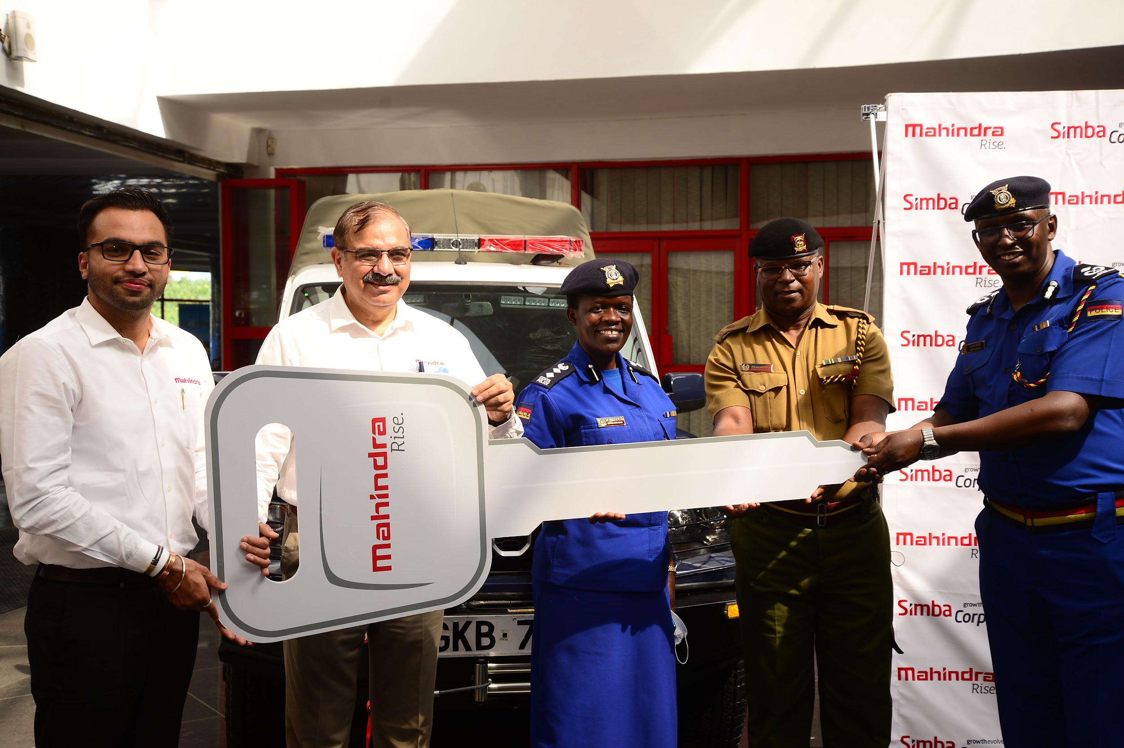
(L-R) Syed Ijazali - Country Head Of Sales & Marketing Mahindra & Mahindra, Naresh Leekha - Simba Corp MD Motors, Dr. Resila Anyango, Mr. J.Mutula and David Njagi-Chief Transport Officer, National Police Service during the handover ceremony of 100 brand new Mahindra Scorpio vehicles to the National Police Service held at Simba Corp Headquarters on Mombasa Road.

David Njagi - Chief Transport Officer, National Police Service, tries out the new Mahindra Scorpio features as Mehul Sachdev - Mahindra Product Manager and Syed Ijazali - Country Head Of Sales & Marketing Mahindra & Mahindra showcase the vehicle’s key features during a handover ceremony of 100 brand new Mahindra Scorpio vehicles to the National Police Service held at Simba Corp Headquarters on Mombasa Road.

